C. V. RAMAN GLOBAL UNIVERSITY

Bhubaneswar, Odisha, India

OPERATING SYSTEM CASE STUDY ON:

A Client Server Application Where 3 Can Use The Concept Of Inter Process Communication, Multithreading, Synchronization

Branch – CSIT
Group - 4
Sub Group- 7

UNDER THE GUIDANCE OF:
Dr. Ram Chandra Barik, Ms. Sibani Baral

DEPARTMENT OF COMPUTER SCIENCE

AND ENGINEERING
SUBMITTED BY:

Name | Regd No.
Srutilochan Dash | 2201020166
Swaraj Sahoo | 2201020168
Anoksha Mohanty | 2201020173
Asit Kumar Barik | 2201020192
Swadesmita Sahoo | 2201020236

ACKNOWLEDGMENT

We would like to extend my sincere gratitude to everyone who contributed to the successful completion of this case study on “A Client Server Application Where 3 Can Use The Concept Of Inter-Process Communication, Multithreading And Synchronization” . Special thanks go to our instructors, Dr. Ramchandra Barik, Ms. Sibani Baral, for their guidance and valuable insights throughout this case study project. Their encouragement and expertise have been crucial in understanding the practical aspects of operating systems and virtualization. We are also grateful to our peers for their support and constructive feedback, which motivated us to delve deeper into this topic. Finally, we would like to acknowledge the valuable resources and documentation on inter-process communication (IPC), multithreading, and synchronization provided by various online platforms, research papers, and textbooks. These references were crucial in understanding the theoretical concepts and practical implementations necessary for developing a robust client-server application.

TABLE OF CONTENTS

Sl. No. | Topic
01 | Introduction
02 | Aim of the project, Key concepts
03 | System architecture overview
04 | Conceptual workflow
05 | Inter-process communication (IPC)
06 | Multithreading
07 | Synchronization
08 | Real-World Case Studies
09 | Code
10 | Output
11 | Challenges & Solutions
12 | Performance Evaluation, Future Enhancement
13 | Conclusion
14 | References

INTRODUCTION

The goal of this exploration is to design and implement a scalable client-server model that can effectively manage multiple concurrent client requests by leveraging Inter-Process Communication (IPC), multithreading, and synchronization techniques. These concepts are crucial for building systems that maintain high performance, responsiveness, and data consistency when handling numerous simultaneous client interactions.

In a typical client-server architecture, the server listens for incoming client requests and processes them accordingly. However, when the server needs to handle multiple clients concurrently, it must rely on IPC methods like sockets, shared memory, and message queues to facilitate communication between the server and the clients, as well as between different server processes or threads. IPC enables the transfer of data, synchronization of tasks, and communication between independent processes or threads running in separate memory spaces.

To improve responsiveness, multithreading is employed, allowing the server to process multiple client requests simultaneously. By spawning separate threads to handle each request, the server can perform tasks in parallel, thus improving throughput and reducing wait times for clients.

However, when multiple threads access shared resources concurrently, synchronization is essential to avoid race conditions, deadlocks, and data inconsistencies. Techniques such as mutexes, semaphores, and locks are used to ensure that only one thread can access a shared resource at a time, maintaining the integrity of the system.

This report will demonstrate how these three core concepts work together to build an efficient, scalable client-server architecture. A Venn diagram will illustrate how IPC, multithreading, and synchronization overlap and complement each other, ensuring smooth and consistent handling of multiple concurrent client requests.

AIM OF THE PROJECT

The aim of this project is to develop a high-performance client-server application capable of handling multiple client requests simultaneously, ensuring both efficiency and data integrity. By utilizing inter-process communication (IPC), multithreading, and synchronization techniques, the system allows for seamless data exchange between clients and the server while enabling concurrent processing. IPC facilitates communication across different processes, ensuring that data is shared securely. Multithreading improves responsiveness by allowing the server to process multiple requests in parallel, reducing delays. Synchronization techniques, such as mutexes and locks, ensure safe access to shared resources, preventing race conditions and ensuring data consistency. This project explores how these mechanisms work together to achieve scalable, reliable, and resilient interactions between clients and the server, even under heavy load.

KEY CONCEPTS

- Inter-Process Communication (IPC)

- Multithreading

- Synchronization

SYSTEM ARCHITECTURE OVERVIEW

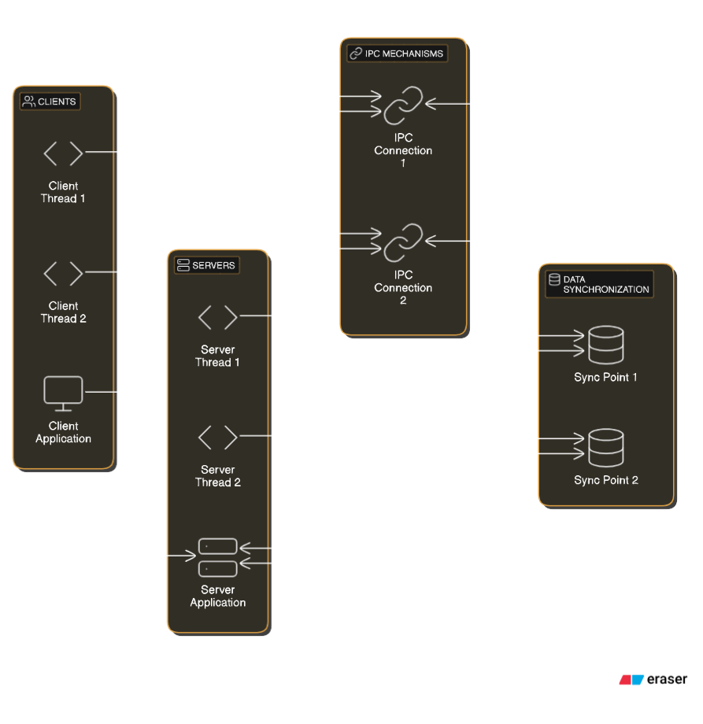

- Client-Server Model: Describes centralized server processing and interacting with multiple client requests.
- Multithreading: Each client request is handled by a separate thread on the server, improving response time.
- IPC Mechanisms: Data exchange methods like shared memory, message queues, and sockets.
- Synchronization: Mechanisms like mutexes and semaphores manage resource access.

CONCEPTUAL WORKFLOW

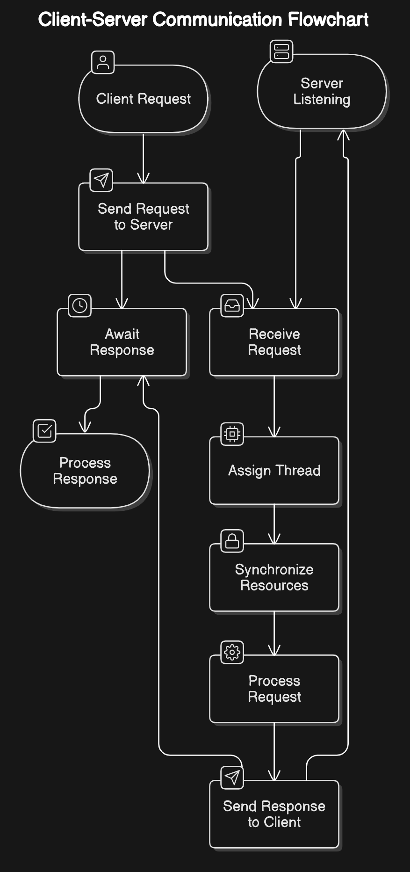

- Client-Side Process: Clients send requests to the server via web or mobile apps and then wait for a response, ensuring a smooth user experience during processing.

- Server-Side Process: The server listens for incoming requests, allocating a separate thread for each to handle multiple requests simultaneously. It uses synchronization to manage shared resources, preventing data inconsistencies and ensuring reliable processing.

INTER-PROCESS COMMUNICATION (IPC)

Inter-Process Communication (IPC) allows separate processes, like client and server, to exchange data and coordinate actions, even across different machines.
IPC Mechanisms Used
In this project, sockets are used for IPC, allowing communication over a network.
- Why Sockets: Sockets support both local and remote communication and are ideal for reliable, real-time client-server interactions.
How IPC is Implemented
- Server Side:
  - The server creates a socket, binds it to a specific IP and port, and listens for client connections.
  - Upon accepting a connection, the server processes requests and sends responses using the connected socket.
- Client Side:
  - The client creates a socket and connects to the server’s IP and port.
  - The client sends requests using send(), and receives responses using recv().
- Data Exchange:
  - The client sends data to the server, which processes it and sends a response back.
- Connection Close:
  - Both client and server close the socket connection after the exchange is complete.

MULTITHREADING

Multithreading allows the server to manage multiple tasks or client requests simultaneously, improving performance, responsiveness, and scalability.
1. Role of Multithreading in Servers
Multithreading allows servers to handle multiple client requests simultaneously, improving efficiency and responsiveness. It enables:
- Concurrency: Processes multiple requests at once, reducing idle time.
- Non-blocking: Other threads continue working while one waits for I/O.
- Scalability: Easily handles increased traffic by adding threads or using thread pools.

2. Thread Management
- Creation: Threads are either created per request or drawn from a pool.
- Thread Pooling: Reuses threads to reduce overhead and improve performance.
- Termination: Threads are terminated or returned to the pool after task completion.

3. Concurrency Handling and Scalability
- Concurrency: Handles multiple requests at once, ensuring responsiveness even with I/O delays.
- Scalability: Increases thread count or adds servers to handle more clients without bottlenecks.

SYNCHRONIZATION
Synchronization is critical in multithreading to prevent data corruption when multiple threads access shared resources. It ensures that threads operate safely and in a controlled manner, avoiding conflicts or errors.

• Thread Safety: Locks like mutexes or semaphores are used to ensure only one thread can access a resource at a time, preventing conflicts.
• Race Conditions: Without synchronization, multiple threads accessing shared data simultaneously can cause errors due to unpredictable execution order.
• Synchronization Techniques:
- Mutexes: Lock a resource so only one thread can access it at a time.
- Semaphores: Control access to a limited number of resources, allowing multiple threads to access concurrently up to a set limit.
- Read-Write Locks: Allow multiple threads to read data simultaneously but give exclusive access to one thread for writing.
- Condition Variables: Let threads wait for specific conditions to be met before proceeding, helping coordinate thread actions.

REAL-WORLD CASE STUDIES
Example 1: Web Servers (Apache and Nginx)
- Multithreading: Web servers like Apache create separate threads for each incoming client request, allowing them to handle multiple requests concurrently. Nginx uses an event-driven, non-blocking model, processing many requests with fewer threads.
- Synchronization: Both servers use synchronization to manage access to shared resources (e.g., databases, file systems), ensuring data consistency when multiple threads access the same resource.
- Real-World Use: Websites like Amazon or Netflix use these servers to handle millions of concurrent user requests, ensuring fast and reliable delivery of content.

Example 2: Database Servers (MySQL, PostgreSQL)
- Multithreading: Database servers handle multiple queries concurrently by using separate threads for each user request, improving query processing speed.
- Synchronization: Databases use locks and transactions to ensure that simultaneous data updates do not lead to conflicts, maintaining consistency and preventing errors.
- IPC: Database systems use inter-process communication to enable coordination between different components (e.g., query processing, cache management).
- Real-World Use: Online platforms like eBay rely on databases like MySQL to process thousands of queries at once, ensuring quick, consistent access to product listings and transactions.

CODE
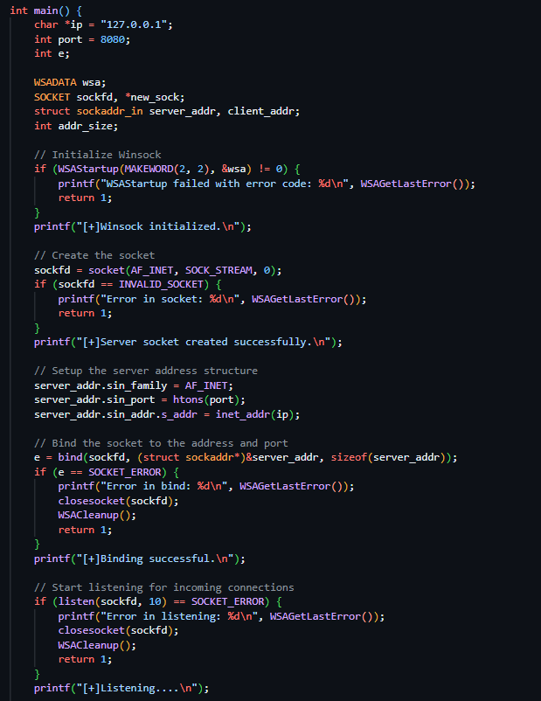
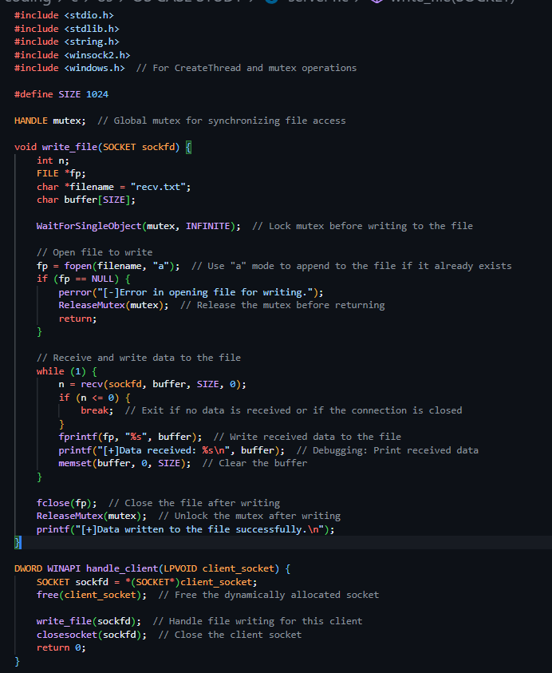
Server-Side Code
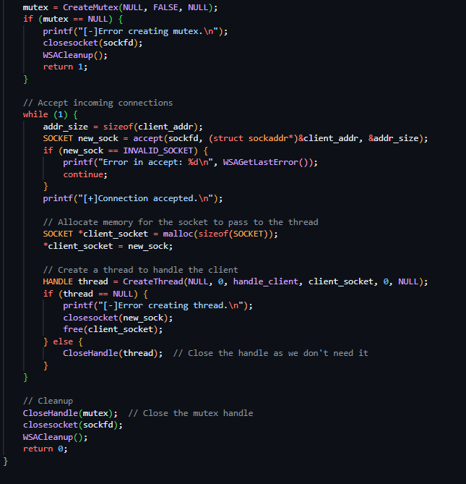

1.Server socket created successfully:
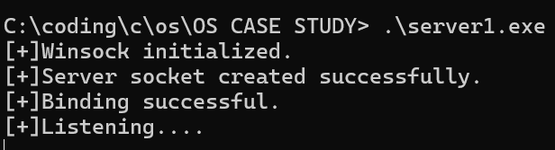

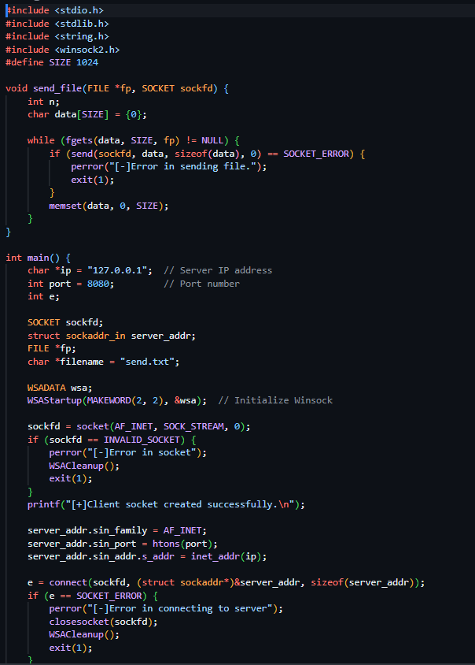
Client-Side Code:
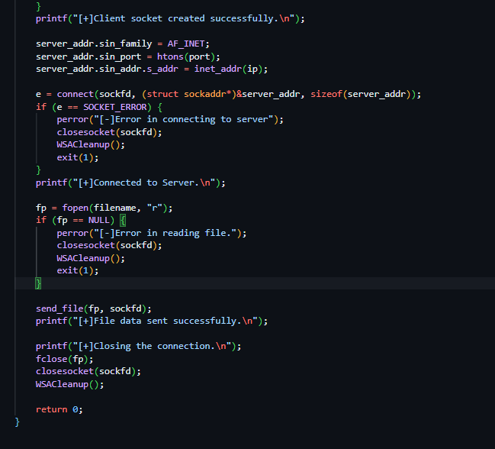
2.Client sent the send.txt file to server:
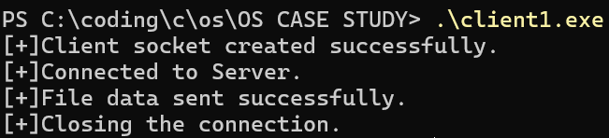
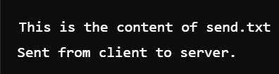
Content of Send.txt :
recv.txt file received after client sent the send.txt file into server :
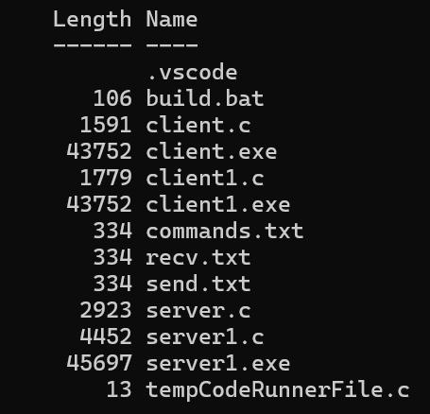
Content of recv.txt (output) :
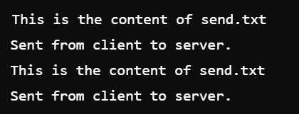

CHALLENGES & SOLUTIONS

Challenge 1: Thread Contention
- Problem: Multiple threads trying to access shared resources simultaneously could lead to conflicts and data corruption.
- Solution: We used mutex locks to ensure only one thread could access a shared resource at a time, ensuring thread safety. Mutexes block other threads from accessing the resource until the current thread completes its operation, thus preventing race conditions and ensuring thread safety.

Challenge 2: Scalability
- Problem: As the number of client requests increased, the system struggled to handle the growing load efficiently.
- Solution: We implemented thread pooling, where a fixed number of threads are reused to handle incoming requests, reducing the overhead of creating and destroying threads for each request. Additionally, load balancing techniques were used to evenly distribute the incoming requests across available threads or servers, ensuring no single resource gets overwhelmed.

Challenge 3: Deadlock Issues
- Problem: Threads could get stuck waiting for each other, causing the system to freeze or slow down.
- Solution: We Implemented timeout mechanisms and ensured careful lock ordering to prevent deadlocks. This helps ensure that threads are able to continue execution and the system remains responsive.

PERFORMANCE EVALUATION

Performance Metrics:
- Response Time: Measures the time taken to respond to client requests. A multithreaded system reduces response time under moderate load but may increase it under heavy traffic.
- Throughput: Indicates how many requests are processed per unit of time. Multithreading improves throughput by handling multiple requests concurrently.
- Resource Utilization: Shows how efficiently system resources (CPU, memory) are used. Poor thread management can lead to high resource consumption, especially under heavy load.

FUTURE ENHANCEMENTS
- Dynamic Thread Pooling: Adjust thread pool size dynamically based on system load to optimize performance and resource usage.

- Fault Tolerance: Implement failover and automatic retries to ensure continuous service and minimize downtime.

- Load Balancing: Distribute incoming requests across servers to prevent overload and improve scalability and availability.

CONCLUSION
This project highlights the effectiveness of a client-server architecture designed to handle multiple concurrent client requests using inter-process communication (IPC), multithreading, and synchronization techniques. By integrating these key concepts, the architecture ensures high concurrency, enabling the server to efficiently manage and process numerous client requests simultaneously.

Multithreading enables parallelism by assigning each request to a separate thread, boosting system throughput and responsiveness. IPC ensures smooth communication between server components (e.g., request handler, database, resource manager), maintaining efficient data flow. Synchronization techniques, like locks and semaphores, prevent race conditions and ensure safe access to shared resources, preserving data integrity and consistency.

The result is a robust and responsive server-side solution capable of providing real-time services in environments requiring high availability, reliability, and security. This combination of IPC, multithreading, and synchronization forms the backbone of modern server architectures, addressing the challenges of managing concurrent workloads while preserving the integrity and security of the system.

REFERENCES

- S.Ghodake, A. R. Buchade, "Survey on Interprocess
Communication and Managment," International Journal
of Innovative Research in Computer and Communication
Engineering, vol. 5, no. 2, pp. 1511-1515, Feb. 2017.

- Lynch, Nancy and Shvartsman, Alex, "Communication
and data sharing for dynamic distributed systems," in
Future directions in distributed computing, 2003, pp. 62-
67.

- D.Ruby, Ms. S.Krishnaveni and Ms., "Comparing and
Evaluating the Performance of Inter Process
Communication Models in Linux Environment,"
lnternational Journal of Trend in Research and
Development (IJTRD), pp. 51-55, Sep. 2016.

- Venkataraman, Aditya and Jagadeesha, Kishore Kumar,
"Evaluation of inter-process communication
mechanisms," Architecture, vol. 86, p. 64, 2015.

